

Practices for Secure Software Report

Table of Contents
Document Revision History 3
Client 3
Instructions 3
Developer 4
1. Algorithm Cipher 4
2. Certificate Generation 4
3. Deploy Cipher 4
4. Secure Communications 4
5. Secondary Testing 4
6. Functional Testing 4
7. Summary 4
8. Industry Standard Best Practices 4

Document Revision History

Version | Date | Author | Comments
1.0 | 21 June 2026 | Ryan Giannelli

Client



Instructions

Submit this completed practices for secure software report. Replace the bracketed text with the relevant information. You must document your process for writing secure communications and refactoring code that complies with software security testing protocols.

- Respond to the steps outlined below and include your findings.
- Respond using your own words. You may also choose to include images or supporting materials. If you include them, make certain to insert them in all the relevant locations in the document.
- Refer to the Project Two Guidelines and Rubric for more detailed instructions about each section of the template.

Developer
Ryan Giannelli

Algorithm Cipher

Recommendation. I recommend the Advanced Encryption Standard with a 256-bit key as the cipher for file encryption, along with SHA-256 for integrity verification. AES-256 is a modern symmetric block cipher that has not been broken and is widely trusted for protecting data at rest. SHA-256 is a cryptographic hash function listed on Oracle’s Java Security Standard Algorithm Names. It is required to be supported by every JDK 9 implementation and produces a 256-bit digest large enough to make collisions practically impossible to find.
Hash functions and bit levels. A hash function takes an input of any size and produces a fixed-length output called a digest. The purpose of a hash is not to encrypt data but to verify integrity. If even one character in a file changes, the hash output changes completely, which makes tampering easy to detect. The bit level refers to the size of the key or digest. A higher bit level means more possible combinations, which makes brute-force attacks much harder. AES-256 uses a 256-bit key, and SHA-256 produces a 256-bit digest.
Random numbers and symmetric vs non-symmetric keys. AES is a symmetric algorithm, which means the same secret key is used to both encrypt and decrypt the data. This is fast and efficient for encrypting large files. Non-symmetric encryption uses a public key and a private key, which is useful for sharing data securely but is slower and less practical for bulk file encryption. Random numbers are important because the secret key must be generated unpredictably. If keys are generated in a predictable way, an attacker could guess them. Java provides secure random number generation through the SecureRandom class.
History and current state. Older ciphers like DES used small 56-bit keys and are no longer considered secure. Triple DES improved on this by running DES three times, but it is slow and is being phased out. AES replaced DES as the modern standard and remains the trusted choice today. For hashing, older algorithms like MD5 and SHA-1 are no longer recommended, which is why the Oracle Java documentation suggests the SHA-2 family like SHA-256. The current state of encryption favors AES for symmetric encryption and SHA-2 for hashing, which is why both are good choices for Artemis Financial.

Certificate Generation
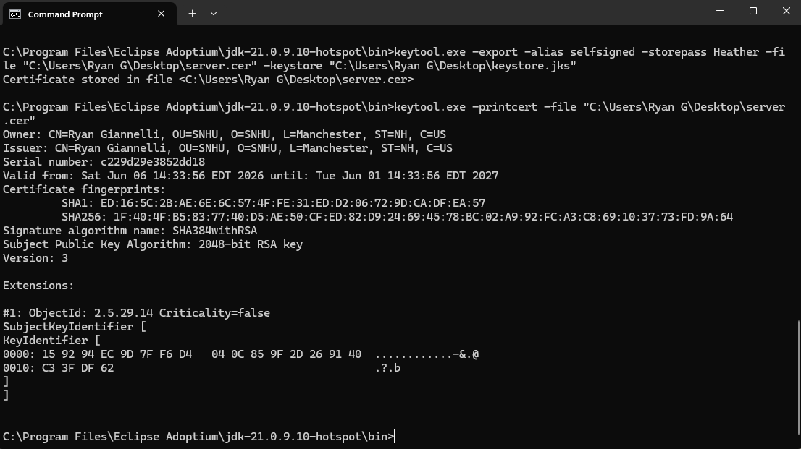

Deploy Cipher

Browser output showing checksum verification with unique data string.
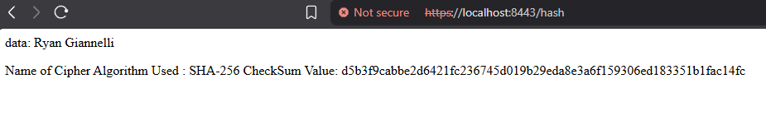

Secure Communications

Browser address bar showing HTTPS protocol at https://localhost:8443


Secondary Testing

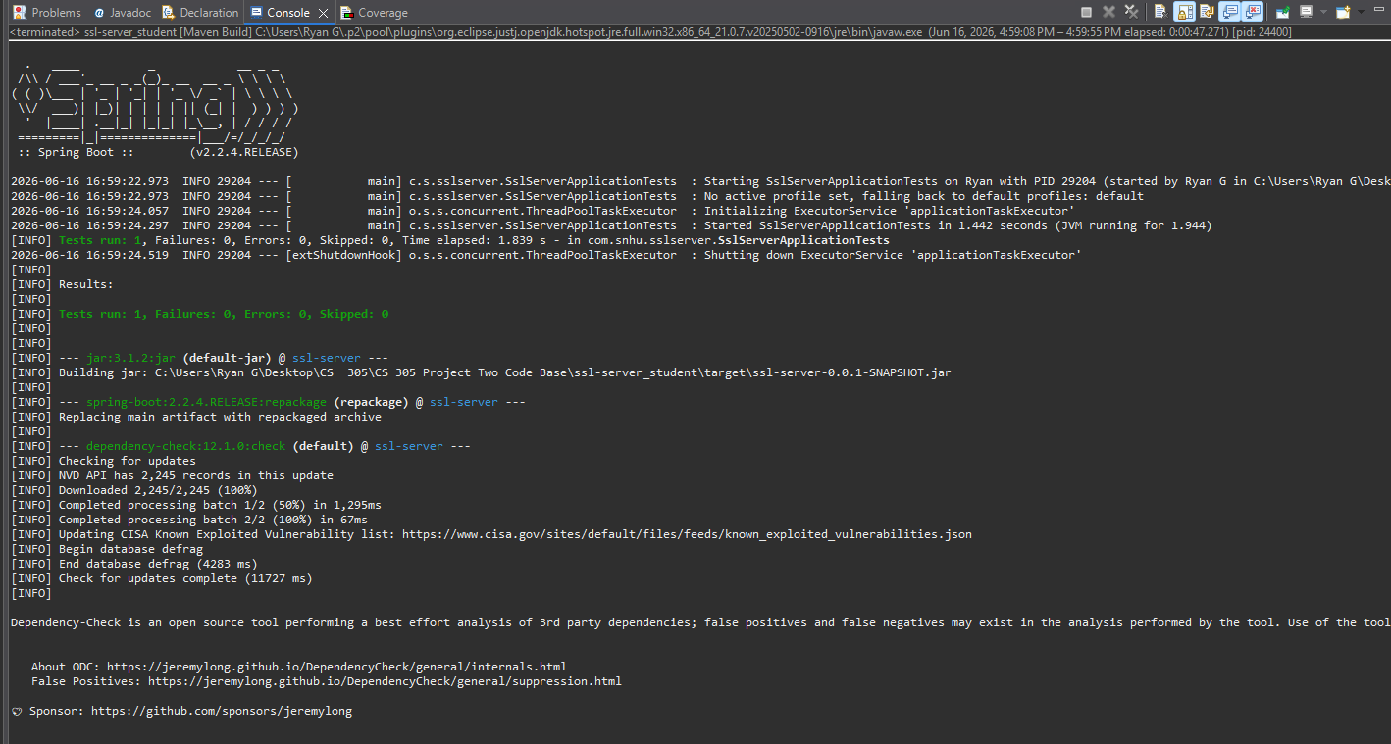
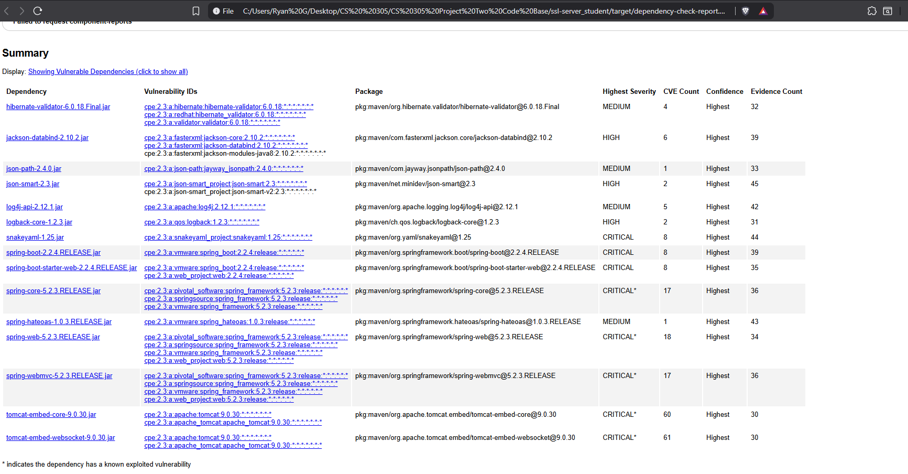

Functional Testing
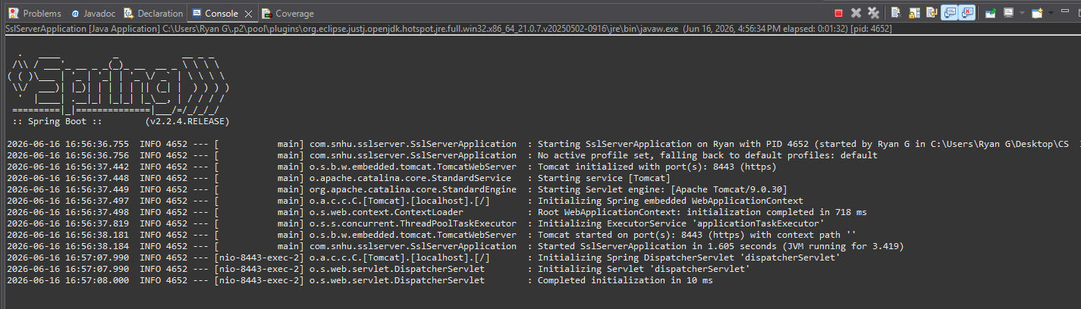

Summary

The refactor added several layers of security to Artemis Financial's application. From to the Vulnerability Assessment Process Flow Diagram, the areas of security addressed are cryptography, secure communications, authentication, and code error handling. The cryptography area was addressed by adding the SHA-256 checksum function for data integrity verification. Secure communications was addressed by enabling HTTPS with TLS using the self-signed certificate, which encrypts traffic between the server and the client. Authentication was addressed at the transport layer through the certificate, which lets the server prove its identity. Code error handling was addressed by adding proper exception handling in the checksum method through the NoSuchAlgorithmException declaration.
The process of adding layers of security was started by reviewing the existing code to understand what was missing. I chose strong algorithms based on the Oracle Java Security Standard Algorithm Name. AES-256 was identified as the recommended cipher for data at rest, and SHA-256 was selected as the collision-resistant hash function for data integrity. I generated a self-signed certificate using the Java Keytool, then configured the application to serve content over HTTPS using that certificate. After implementing the checksum endpoint, I ran static testing with OWASP dependency-check to confirm that my refactor did not introduce new vulnerabilities. Each layer was tested before moving to the next.

Industry Standard Best Practices

I applied industry standard best practices throughout the refactor to mitigate known security vulnerabilities. I used the Oracle Java Security Standard Algorithm Names as the source for choosing algorithms, which made the application up to date with current standards. I avoided deprecated algorithms like MD5, SHA-1, and DES because they have known weaknesses. I used Java's built-in MessageDigest class instead of writing custom cryptographic code, which follows the standard guidance of never rolling your own crypto. I enabled HTTPS to encrypt data in transit, which is an expectation for any application handling financial data. I also ran OWASP dependency-check as part of the build process, which is a standard DevSecOps practice for catching vulnerable third-party libraries early.

Applying these practices is valuable to Artemis Financial in many important ways. It protects customer financial data from common attack patterns, which reduces the risk of breaches and the costs that come with them. It helps the company meet regulatory requirements like the Gramm-Leach-Bliley Act, which mandates protection of customer financial information. It builds trust with customers, who are more likely to do business with a company that visibly takes security seriously. Following standard practices also makes the code easier for other developers to maintain, since the patterns and tools used are familiar across the industry.
References

Oracle. (n.d.). Java security standard algorithm names. Oracle Help Center. https://docs.oracle.com/javase/9/docs/specs/security/standard-names.html

Oracle. (n.d.). keytool – Key and certificate management tool. Oracle Help Center.
https://docs.oracle.com/javase/8/docs/technotes/tools/windows/keytool.html

OWASP. (n.d.). OWASP dependency-check. https://jeremylong.github.io/DependencyCheck/

